Installation Manual

Version IM-3-6-23-2014

For

PlasmaGraph

|  |  |  |
| --- | --- | --- |
| Daniel E. Quintini Greco |  | Gerardo A. Navas Morales |
| Computer Science Undergraduate Program |  | Computer Science Undergraduate Program |

Polytechnic University of Puerto Rico

Electrical & Computer Engineering and Computer Science Department

June 23, 2014

Revision History

|  |  |  |  |
| --- | --- | --- | --- |
| **Name** | **Date** | **Reason For Changes** | **Version** |
| Daniel E. Quintini Greco | 5/25/2014 | Initial version. | 2-5-25-2014 |
| Daniel E. Quintini Greco | 5/28/2014 | Minor corrections for final version. | 3-5-28-2014 |
| Gerardo A. Navas Morales | 6/23/2014 | Updating Installation Manual before providing program and documentary material to PUPR Plasma Laboratory Users. | 3-6-23-2014 |

Table of Contents

1. Introduction 1

1.1 Overview 1

1.2 Audience 1

2. Installing PlasmaGraph 2

2.1 Requirements 2

2.2 Step 1: Install Java 3

2.3 Step 2: Run PlasmaGraph 3

3. References 4

# Introduction

## Overview

PlasmaGraph is a software tool designed for optimizing the process of gathering and analyzing output data produced by the mirror and cusp plasma machine at the PUPR by letting the user generate graphs with this data. In other words, PlasmaGraph uses data files produced by the plasma machine in order to generate graphs that can be saved as images in the user’s personal computer.

This manual will explain all the steps necessary to install PlasmaGraph in any personal computer that supports Java [1].

## Audience

This document is intended for researchers interested in using PlasmaGraph for analyzing data.

# Installing PlasmaGraph

## Requirements

Potential users must have a computer with the following specifications in order to run this program with the same benchmarks as described in PlasmaGraph’s Software Requirement Specifications document:

1. 15’’ Monitor with a resolution of 1200x700 and refresh rate of 30Hz
2. A standard alphanumeric American (QWERTY) keyboard
3. One 3.20GHz dual core processor
4. 500Mb of available HDD
5. 512Mb of RAM

In addition, the following will be necessary in order to install the newest version of Java:

1. Computer with an internet connection
2. Internet Browser (such as Microsoft Internet Explorer, Mozilla Firefox, Google Chrome)

## Step 1: Install Java

To install Java go to their official website and follow the instructions provided under the option “help resources >> installing Java”. Alternatively, you can go to Java’s installation instructions page using the following URL: <http://www.java.com/en/download/help/download_options.xml>

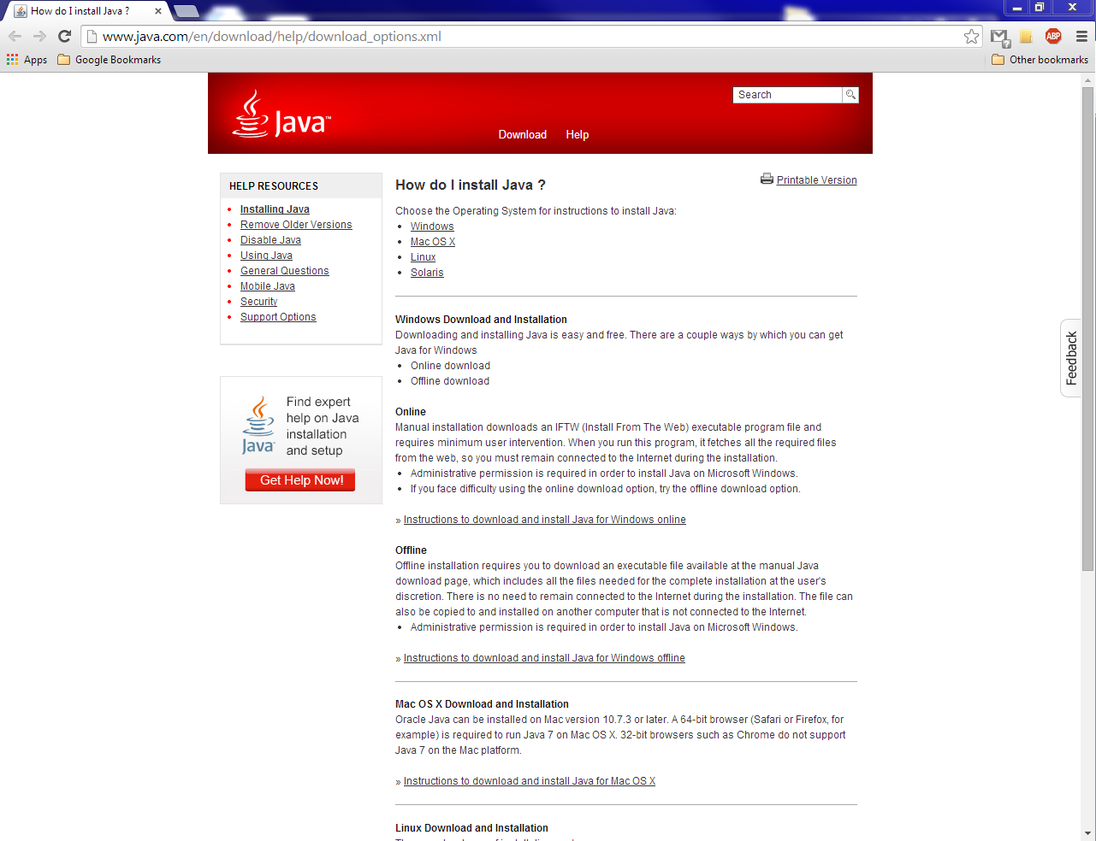

Figure 2‑1: Java website

## Step 2: Run PlasmaGraph

Double click on the “plasmagraph.jar” program icon to run the PlasmaGraph program.

# References

|  |  |
| --- | --- |
| [1] | Oracle Corporation, "Learn About Java Technology," [Online]. Available: https://www.java.com/en/about/. [Accessed 21 1 2014]. |